Live & Learn Email Signature instructions

There are two email signature style options for Live & Learn. Please ensure that you use one of these on all emails sent from your Live & Learn email address.
On 'reply' emails you can use a shortened version, but ensure that you follow the same format/style as your 'normal' signature. Most email programs allow for more than one email signature, so you set one signature for 'new' emails and set another as your 'reply' signature.
The disclaimer (the small italic text This email and any attachments ...) at the end of your signature is important to have at least once in your email message. This protects both yourself as well as the Live & Learn group. If you have a few replies on the same email conversation, it is not required to have the disclaimer included every time - once is enough.
Below are two options to pick your signature from. Decide which you would like to use and then follow the instructions to set it to your email program.

Option 1: Email signature (with logo)

YourName Surname - YourPosition Title
Live & Learn International
0421 123 123
livelearn.org | LinkedIn | Twitter | Facebook | Instagram
This email and any attachments may contain legally privileged or confidential information and may be protected by copyright. You must not use or disclose them other than for the purposes for which they were supplied. The privilege or confidentiality attached to this message and attachments is not waived by reason of mistaken delivery to you. If you are not the intended recipient, you must not use, disclose, retain, forward or reproduce this message or any attachments. If you receive this message in error, please notify the sender by return email or telephone and destroy and delete all copies.

Option 2: Email signature 'Reply' Example: (no logo)

YourName Surname - YourPosition Title
Live & Learn International
0421 123 123
This email and any attachments may contain legally privileged or confidential information and may be protected by copyright. You must not use or disclose them other than for the purposes for which they were supplied. The privilege or confidentiality attached to this message and attachments is not waived by reason of mistaken delivery to you. If you are not the intended recipient, you must not use, disclose, retain, forward or reproduce this message or any attachments. If you receive this message in error, please notify the sender by return email or telephone and destroy and delete all copies.

Instructions:
- Open your email program and navigate to the Signature settings section.
- Click, hold and drag to highlight the signature option that you want to use. Make sure to highlight everything from " YourName ..." all the way to "... delete all copies.". Now 'Copy' the highlighted text.
- Go back to your email program settings part, name your signature and then 'Paste' your signature. Make sure it looks the same as the option you selected. In some programs you need to make sure the 'plain text' option is off or not ticked. You want to either use 'rich text' or 'html' before you paste.
- Save the signature (OK). Open the signature again. Click on the signature text in the settings part and change the text to include your personal details (name, position, phone number). The fonts, colours and sizes from the sample should stay in place.
*see further down how to add Facebook and LinkedIn links.
- Some programs will not Copy and Paste the logo image. If yours does not, you will need to click where the image is supposed to be and add it manually, with 'insert image'. ** Copy the web address for the image below and paste it in the 'insert image' dialogue.
Logo image source web address: https://livelearn.org/logo-resources
*example: https://livelearn.org/assets/media/brand/Signature_LLEE.png
- Save once more and inspect the result.
- Close then restart your email program completely so that the settings can reload properly. Click ‘new email’ and see if the new signature has been added.
Now email yourself, and when the email arrives, see if it is displaying correctly, but also check the links to make sure they are correct.

Adding your LinkedIn and Facebook 'pages' links.
- Open your web browser on the page that you need. For example: https://www.facebook.com/LiveAndLearnInternational
- 'Copy' the url from the address bar in your browser.
- Now back in your signature edit, double click to select the entire word (Facebook, LinkedIn, Twitter or Instagram)
- While highlighted, 'right-click' on the word, and pick 'Hyperlink'. 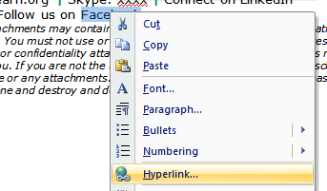
- 'Paste' the link, from step 2, in the ‘Address’ field, and OK.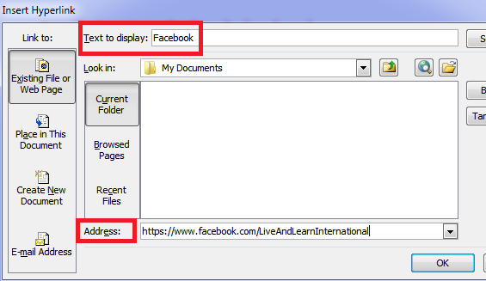
- Your link-word should now change colour with an underline and link active.
Always test your signature. You can do that by emailing yourself to 1. see what it looks like and 2. make sure the links are working correctly.

Technical:

Font: Verdana
Size: 10
Colour: rgb(38,38,38) / #262626
Sample: YourPosition

Highlight Font: Verdana, Bold
Highlight Size: 12
Highlight Colour: rgb(0,0,0) / #000000
Sample: Live & Learn

Highlight Colour: rgb(0,140,105) / #008c69
Sample: livelearn.org

Disclaimer Font: Verdana
Disclaimer Size: 8
Disclaimer Colour: rgb(128,128,128) / #808080
Sample: This email and any

Live & Learn website url:
https://livelearn.org/

Signature logo image embed web source:
See your country specific image url on this page
https://livelearn.org/logo-resources
*example: https://livelearn.org/assets/media/brand/Signature_LLEE.png

